Southern University of Science and Technology

Master’s Thesis Proposal

Title：

Department

Discipline

Supervisor

Student Name

Student Number

Date of Proposal Report

Graduate school

TABLE OF CONTENTS
CHAPTER 1 TITLE 1
1.1 Title 1
1.2 Tables, Figures and Equations 1
1.2.1 Tables 1
1.2.2 Figures 2
1.2.3 Equations 2
CHAPTER 2 TITLE 3
2.1 Title 3
2.1.1 Title 3
CHAPTER 3 TITLE 5
3.1 Title 5
3.1.1 Title 5
CHAPTER 4 TITLE 6
4.1 Title 6
4.1.1 Title 6
CHAPTER 5 TITLE 7
5.1 Title 7
5.1.1 Title 7
CHAPTER 6 TITLE 8
6.1 Title 8
6.1.1 Title 8
REFERENCES 10

TITLE

Title
Cells function is mainly determined by gene expression which is precisely controlled at space and time for every step, transcription, RNA 5’ capping, splicing, RNA polyadenylation, and translation.……

Tables, Figures and Equations

Tables
Fonts and point sizes for the thesis are summarized in Table 1-1.
Table 1-1 Typeface and spacing of a thesis
Contents | Fonts and point sizes |  | Line Spacing | Paragraph Spacing
 | English | Chinese |  | Before | After
Level 1 headings | Arial 16 pt Bold | 黑体 16 pt Bold | 20 pt | 24pt | 18pt
Level 2 headings | Arial 14 pt Bold | 黑体 14 pt Bold | 20 pt | 24pt | 6pt
Level 3 headings | Arial 13 pt Bold | 黑体 13 pt Bold | 20 pt | 12pt | 6pt
Level 4 headings | Arial 12 pt Bold | 黑体 12 pt Bold | 20 pt | 12pt | 6pt
Table headings | Times New Roman 11 pt |  | Single-spaced | 12pt | 6pt
Text in tables | Times New Roman 11 pt |  | Single-spaced | 3pt | 3pt
Figure captions | Times New Roman 11 pt |  | Single-spaced | 6pt | 12pt
Text in figures | Times New Roman 9-10.5 pt |  | / | / | /
Equations | Xits Math 12pt or  Cambria Math 12 pt or  Times New Roman 12 pt |  | Single-spaced | 6pt | 6pt
Notes for tables/figures | Times New Roman 10.5 pt |  | Single-spaced | 6pt | 12pt
Text of references | Times New Roman 10.5 pt |  | 16 pt | 3pt | 0pt
 |  |  | (Continued)
Table 1-1 (Continued) Typeface and spacing of a thesis
Contents | Fonts and point sizes |  | Line Spacing | Paragraph Spacing
 | English | Chinese |  | Before | After
Page headers/numbers | Times New Roman 10.5 pt | 宋体 10.5 pt | Single-spaced | 0pt | 0pt
Text (format not specifically indicated) | Times New Roman 12 pt | 宋体 12 pt | 20 pt | 0pt | 0pt

Figures
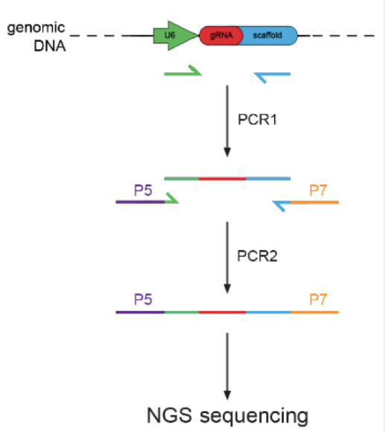
……Procedure can be seen in Figure 1-1.
Figure 1-1 Construction of CRISPR screen sequencing library
Raw data in fast q format was processed with MAGeCK and visualized with VISPR. Prominent genes were filtered out based on the enrichment level in both control and experimental groups.

Equations
Main text……Equation (1-1) is……
$$f\left(x\right)=a_{0}+\sum_{n=1}^{∞}{\left(a_{n}\cos{\frac{nπx}{L}}+b_{n}\sin{\frac{nπx}{L}}\right)}$$ | (1-1)

TITLE

Title
Main text …… Figure 2-1 illustrates……
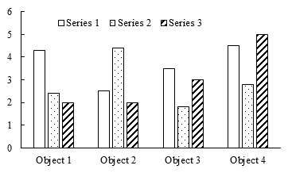
Figure 2-1 Caption

Title
Main text……Equation (2-1) is……

$$f\left(x\right)=a_{0}+\sum_{n=1}^{∞}{\left(a_{n}\cos{\frac{nπx}{L}}+b_{n}\sin{\frac{nπx}{L}}\right)}$$ | (2-1)
……
Main text …… Table 2-1 shows……
Table 2-1 Title
Header 1 | Header 2 | Header 3 | Header 4
Row 1
Row 2
Row 3
Row 4
Row 5
Row 6
 |  |  | (Continued)
Table 2-1 (Continued) Title
Header 1 | Header 2 | Header 3 | Header 4
Row 7
Row 8
Row 9
Row 10
Row 11

TITLE

Title
Main text

Title
Main text

Main text……Equation (3-1) is……
$$f\left(x\right)=a_{0}+\sum_{n=1}^{∞}{\left(a_{n}\cos{\frac{nπx}{L}}+b_{n}\sin{\frac{nπx}{L}}\right)}$$ | (3-1)

TITLE

Title
Main text

Title
Main text

Main text……Equation (4-1) is……
$$f\left(x\right)=a_{0}+\sum_{n=1}^{∞}{\left(a_{n}\cos{\frac{nπx}{L}}+b_{n}\sin{\frac{nπx}{L}}\right)}$$ | (4-1)

TITLE

Title
Main text

Title
Main text

Main text……Equation (5-1) is……
$$f\left(x\right)=a_{0}+\sum_{n=1}^{∞}{\left(a_{n}\cos{\frac{nπx}{L}}+b_{n}\sin{\frac{nπx}{L}}\right)}$$ | (5-1)

TITLE

Title
Main text

Title
Main text

Main text……Equation (6-1) is……
$$f\left(x\right)=a_{0}+\sum_{n=1}^{∞}{\left(a_{n}\cos{\frac{nπx}{L}}+b_{n}\sin{\frac{nπx}{L}}\right)}$$ | (6-1)

REFERENCES

- LIN S D. Water and wastewater calculations manual[M]. New York: McGraw-Hill, 2001.
- GAO H, GALLAGHER K P. World needs stronger financial safety net[N/OL]. China Daily,2020-11-19[2020-11-20].
http://epaper.chinadaily.com.cn/a/202011/19/WS5fb5a952a31099a234351e21.html.
- JHA M, GASSMAN P W, SECCHI S, et al. Effect of watershed subdivision on SWAT flow, sediment, and nutrient predictions[J]. Journal of the American Water Resources Association, 2004, 40(3):811-825.
- KOECHLING M T. Assessment and modeling of chlorine reactions with natural organic matter: Impact of source water quality and reaction conditions[D]. Cincinnati: University of Cincinnati, 1998.
- U.S. Environmental Protection Agency. Guidelines for ecological risk assessment[R/OL]. Washington, DC: U.S. Environmental Protection Agency,1998[2020-11-20].https://www.epa.gov/sites/production/files/2014-11/documents/eco_risk_ass-essment1998.pdf.
- U.S. Environmental Protection Agency. 2018 Edition of the drinking water standards and health advisories tables[S/OL]. Washington, DC: U.S. Environmental Protection Agency,2018[2020-11-20]. https://www.epa.gov/sites/production/files/2018-03/documents/dwtable2018.pdf.
- U.S. Environmental Protection Agency. Environment Fluid Dynamics Code: EPA version 1.01 [CP/OL]. Washington, DC: U.S. Environmental Protection Agency, 2007[2020-11-20]. https://www.epa.gov/ceam/environment-fluid-dynamics-code-efdc-download-page.
- Environment Agency, Department for Environment, Food & Rural Affairs. Discharges to surface water and groundwater: environmental permits [EB/OL]. (2016-02-01)[2020-11-20]. https://www.gov.uk/guidance/discharges-to-surface-water-and-groundwater-environmental-permits.
- PAPWORTH A, FOX P, ZENG GT, et al. Ability of aluminum alloy to wet alumina fibres by addition of bismuth[J]. Mater Sci & Technol, 1999, 15(4):419-428.
- ……

